14.1.6 Editors - Movie Clip Editor - Header - Tracking Mode - Graph Submode - Graph Menu
Track Menu 1
Delete Curve 1
Delete Knot 1
Clear Track Path Remained 1
Clear Track Path Up To 1
Clear Track Path All 1
Disable Markers 1
Move 1
Rotate 2
Resize 2

Track Menu

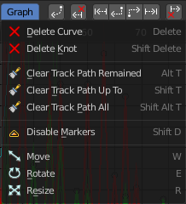
Delete Curve
Deletes the track that correspondend to the current curve.

Delete Knot
Deletes the selected curve points.

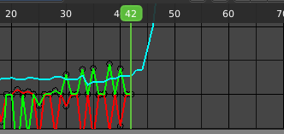
Clear Track Path Remained
Clears the track path after the current position.

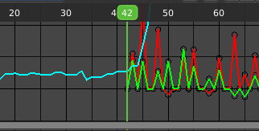
Clear Track Path Up To
Clears the track path up to the current position.

Clear Track Path All
Clears the complete track path.

Disable Markers
Disables the selected curve points.

Move
Moves the selected curve points.

Rotate
Rotates the selected curve points.

Resize
Scales the selected curve points.

